

ASSIGNMENT #1

Course: Compiler Construction
Instructor: Mr. Nirmal Tariq

BY:
Ruhab Ahmad (23I-0559)
Hasan Altaf (23I-0698)
Degree: Computer Science
Section: E
FAST - NUCES

REGULAR EXPRESSIONS
- Integer Literal
Regex: [+-]?[0-9]+
Description: Optional sign followed by one or more digits
- Floating-Point Literal
Regex: [+-]?[0-9]+\.[0-9]{1,6}([eE][+-]?[0-9]+)?
Description: Optional sign, digits, decimal point, 1-6 decimal digits, optional exponent
- Identifier
Regex: [A-Z][a-z0-9_]{0,30}
Description: Starts with uppercase letter, followed by 0-30 lowercase letters, digits, or underscores
- Single-line Comment
Regex: ##[^\n]*
Description: followed by any characters except newline
- Multi-line Comment (Additional)
Regex: #\*(([^*]|\*+[^*#])*)\*+#
Description: #* ... *# with proper nesting handling
- String Literal (Additional)
Regex: "([^"\\\n]|\\[ "\\ntr])* "
Description: Double-quoted string with escape sequences
- Arithmetic Operators (Additional)
Regex: (\*\*|[+\-*/%])
Description: **, +, -, *, /, %

NFAs
- Integer Literal:
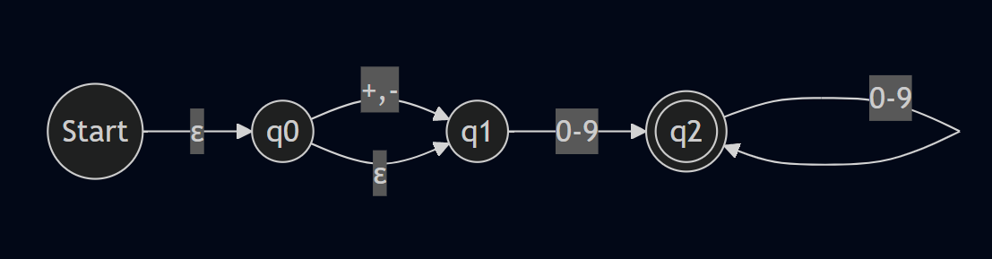
- Floating-Point Literal:
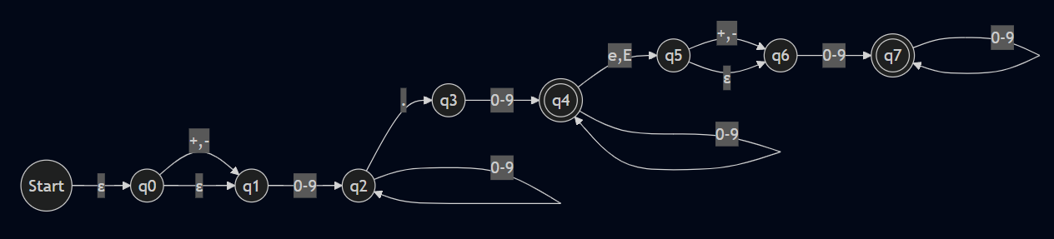
- Identifier:
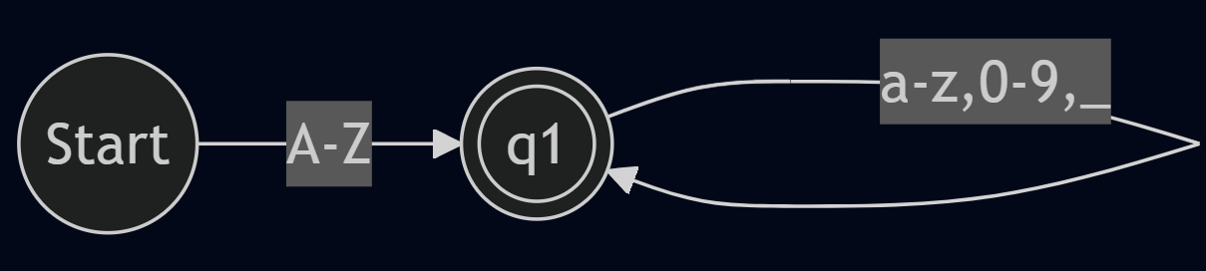
- Single-Line Comment:
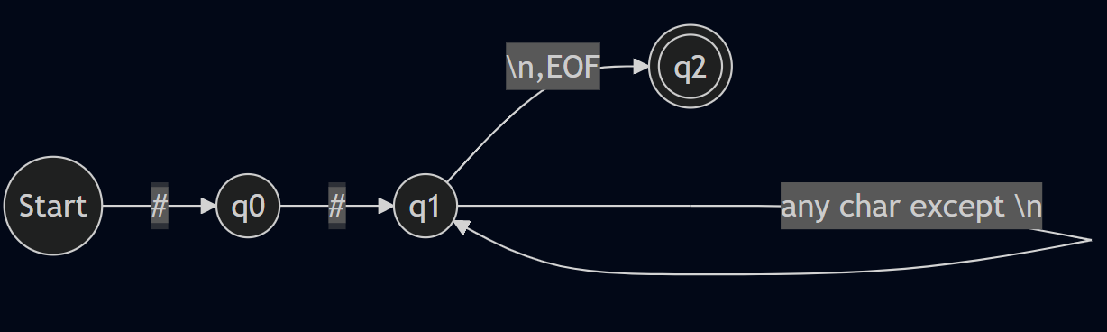
- Multi-Line Comment:
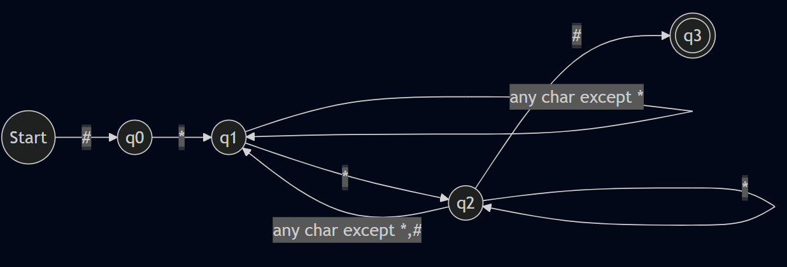
- String Literal:
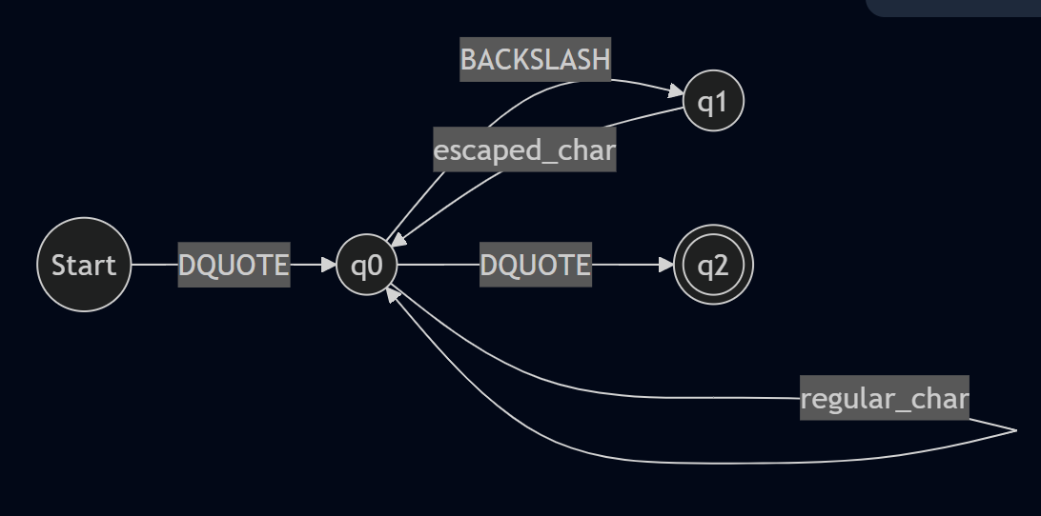
- Arithmetic Operators:
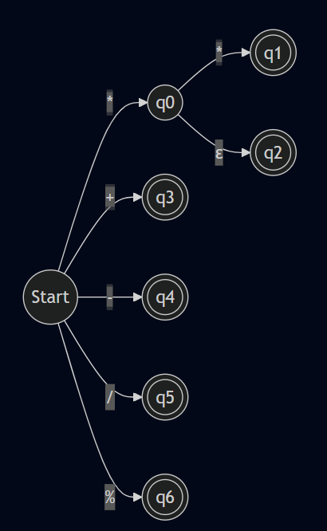

COMBINED NFA:
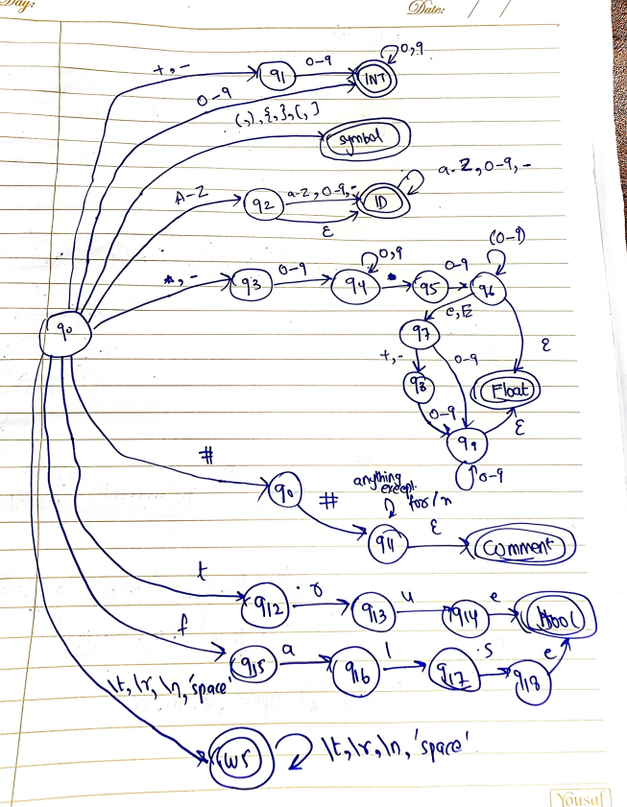

DFAs
- Integer Literal:
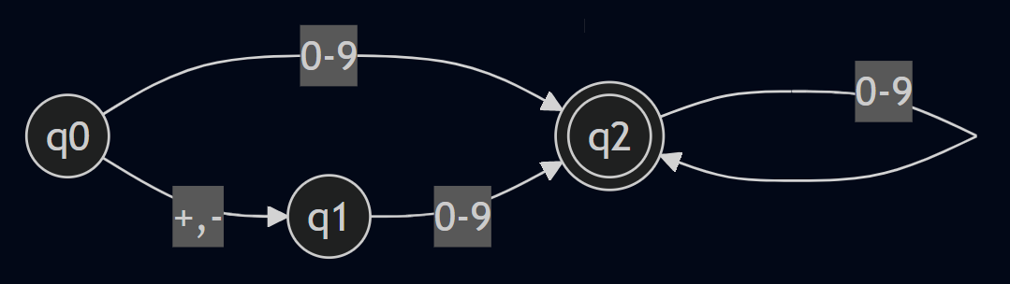
- Floating-Point Literal:
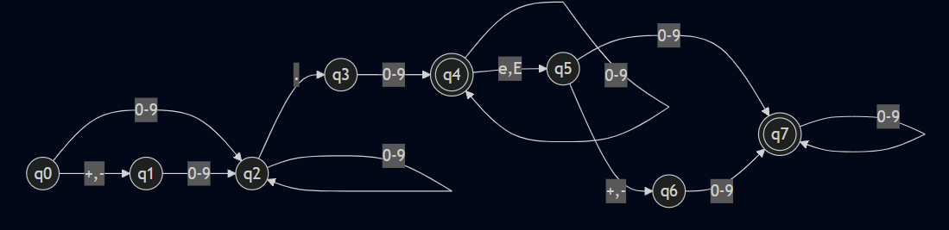
- Identifier:
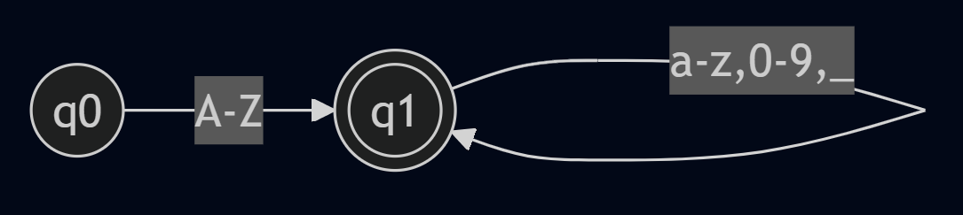
- Single-Line Comment:
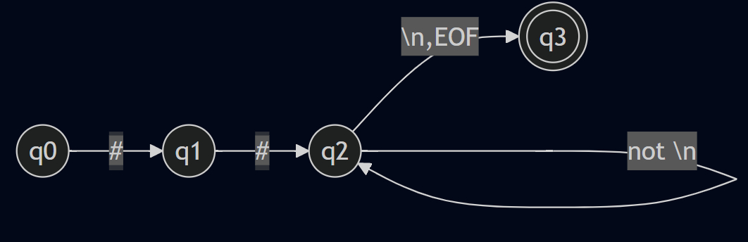
- Multi-Line Comment:
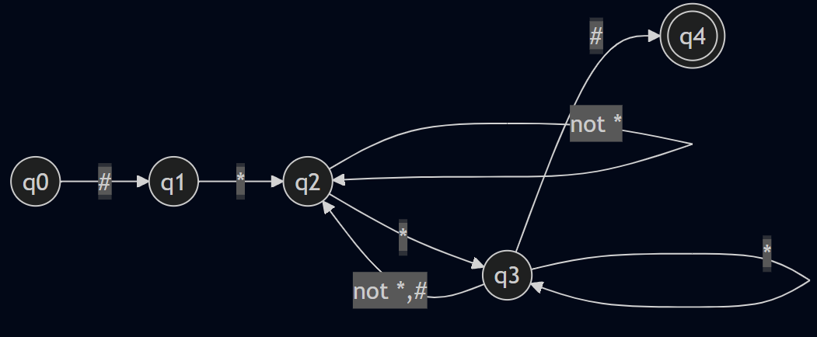
- String Literal:
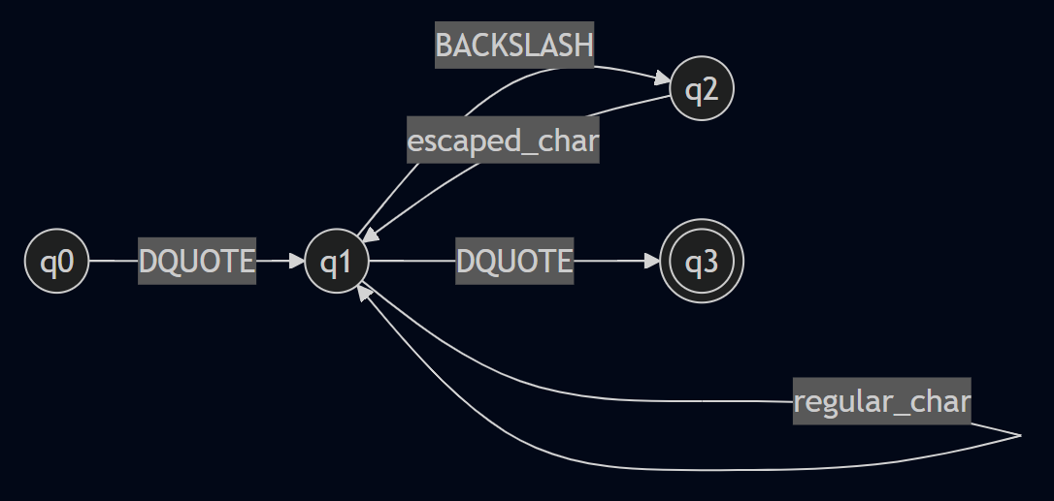
- Arithmetic Operators:
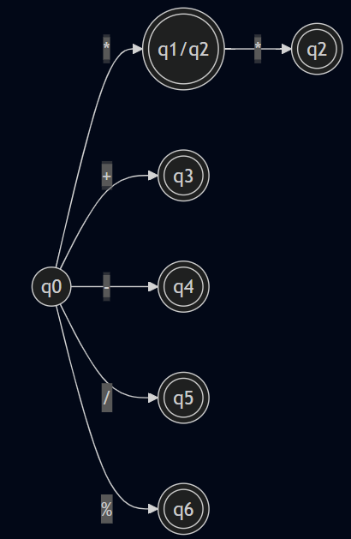

COMBINED DFA:
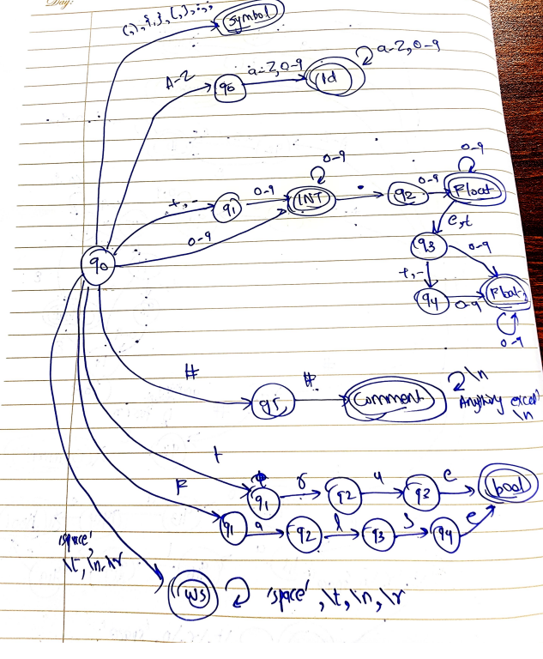

Transition Tables
- Integer Literal DFA Transition Table
State | + - | 0-9 | Accepting
q0 | q1 | q2 | No
q1 | - | q2 | No
q2 | - | q2 | Yes
- Floating-Point Literal DFA Transition Table
State | +,- | 0-9 | . | e,E | Accepting
q0 | q1 | q2 | - | - | No
q1 | - | q2 | - | - | No
q2 | - | q2 | q3 | - | No
q3 | - | q4 | - | - | No
q4 | - | q4 | - | q5 | Yes
q5 | q6 | q7 | - | - | No
q6 | - | q7 | - | - | No
q7 | - | q7 | - | - | Yes
- Identifier DFA Transition Table
State | A-Z | a-z,0-9,_ | Accepting
q0 | q1 | - | No
q1 | - | q1 | Yes
- Single-line Comment DFA Transition Table
State | # | not \n | \n,EOF | Accepting
q0 | q1 | - | - | No
q1 | q2 | - | - | No
q2 | q2 | q2 | q3 | No
q3 | - | - | - | Yes
- Multi-line Comment DFA Transition Table
State | # | * | other | Accepting
q0 | q1 | - | - | No
q1 | - | q2 | - | No
q2 | - | q3 | q2 | No
q3 | q4 | q3 | q2 | No
q4 | - | - | - | Yes
- String Literal DFA Transition Table
State | " | \ | regular | ",,n,t,r | Accepting
q0 | q1 | - | - | - | No
q1 | q3 | q2 | q1 | - | No
q2 | - | - | - | q1 | No
q3 | - | - | - | - | Yes
- Arithmetic Operators DFA Transition Table
State | * | + | - | / | % | Accepting
q0 | q1 | q3 | q4 | q5 | q6 | No
q1 | q2 | - | - | - | - | Yes (*)
q2 | - | - | - | - | - | Yes (**)
q3 | - | - | - | - | - | Yes (+)
q4 | - | - | - | - | - | Yes (-)
q5 | - | - | - | - | - | Yes (/)
q6 | - | - | - | - | - | Yes (%)

